Introduction to computer networks

Introduction to computer hardware: Introduction to important components of a computer system such as

* Mother Board
* RAM Modules
* Daughter cards
* Bus slots
* SMPS
* Internal storage devices
* Interfacing ports

Mother Boards

A motherboard provides connectivity between the hardware components of a computer, like the processor (CPU), memory (RAM),hard drive, and video card. There are multiple types of motherboards, designed to fit different types and sizes of computers.

Each type of motherboard is designed to work with specific types of processors and memory, so they don't work with every processor and type of memory. However, hard drives are mostly universal and work with the majority of motherboards, regardless of the type or brand.

**Where is the motherboard located?**

A computer motherboard is located inside the computer case and is where most of the parts and computer peripherals connect. With [tower computers](https://www.computerhope.com/jargon/t/tower.htm), the motherboard is on the left or right side of the tower and is the biggest [circuit board](https://www.computerhope.com/jargon/p/pcb.htm).

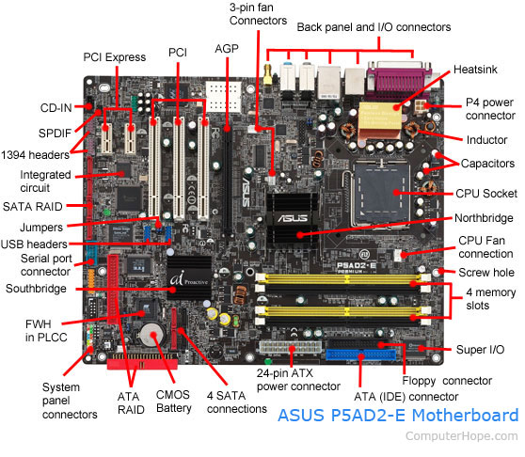Types of Motherboard

#### 1. AT Motherboard

These motherboards have bigger physical dimensions of hundreds of millimeters and hence they are not the right fit for the mini desktop category of computers. Bigger physical size also inhibits installing new drivers. Sockets and six-pin plugs are used as power connectors in these motherboards. These power connectors are not that easily identifiable and hence users face difficulties in connecting and using it.

#### 2. ATX Motherboard

ATX denotes Advanced technology extended, it was developed by Intel during the 1990s and it was an improved version over an earlier version of AT motherboard. It is smaller in size when compared to AT and it provides interchangeability of the connected components. There is a marked improvement in the connector aspects.

#### 3. LPX Motherboard

This board had two improvements over earlier versions. The first one is Input and Output ports were taken to backside and the second one was the introduction of Riser card to facilitate more slots and easier connection. Some of these features were deployed in the AT motherboard. The main disadvantage in this board is the lack of Accelerated Graphic Port (AGP) slots which led to a direct connection to PCI. Issues in these motherboards were addressed in NLX boards.

#### 4. BTX Motherboard

BTX denotes Balanced Technology Extended, intended to manage demands of new technologies in terms of more power requirements hence generation of more heat. Intel stopped further development of BTX boards during the mid-2000s to concentrate on low power CPU.

RAM Modules

## memory module

A narrow printed circuit board that holds memory chips (RAM chips). The common architecture for desktop computers is the dual in-line memory module (DIMM), which transfers 64 bits at a time. Because of space limitations, laptops use small outline DIMMs (SODIMMs). The modules are keyed with notches in different places so they cannot be inserted into the wrong slots (see below). See [**RAM**](https://encyclopedia2.thefreedictionary.com/RAM).  
  
**Error Detection and Correction**  
Most desktop and laptop computers use RAM chips that hold eight bits per byte, while high-end servers and workstations typically have nine bits. The ninth bit is a parity bit for detecting errors. See [**ECC memory**](https://encyclopedia2.thefreedictionary.com/ECC+memory) and [**RDIMM**](https://encyclopedia2.thefreedictionary.com/RDIMM).  
  
**Upgrading Memory - Read the Manual (RTFM!)**  
A single DIMM can often be used, but pairs of DIMMs increase performance in machines that support dual channel DDR SDRAM. When upgrading memory, read the motherboard manual to find out which module combinations can be used. See [**MT/sec**](https://encyclopedia2.thefreedictionary.com/MT%2fsec), [**SDRAM**](https://encyclopedia2.thefreedictionary.com/SDRAM), [**memory types**](https://encyclopedia2.thefreedictionary.com/memory+types), [**memory card**](https://encyclopedia2.thefreedictionary.com/memory+card) and [**Hybrid Memory Cube**](https://encyclopedia2.thefreedictionary.com/Hybrid+Memory+Cube).

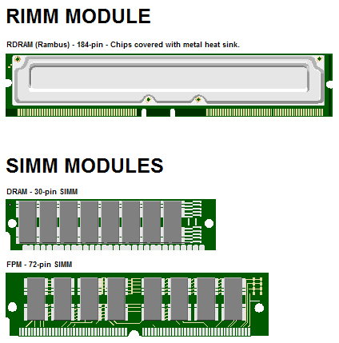

Daughter cards

A [printed circuit board](https://www.webopedia.com/definitions/printed-circuit-board/) that plugs into another circuit board (usually the [motherboard](https://www.webopedia.com/reference/motherboards/)). A daughtercard is similar to an [expansion board](https://www.webopedia.com/definitions/expansion-board/), but it accesses the motherboard components ([memory](https://www.webopedia.com/definitions/memory/) and [CPU](https://www.webopedia.com/definitions/cpu/)) directly instead of sending data through the slower [expansion bus](https://www.webopedia.com/definitions/expansion-bus/).

A daughtercard is also called a *daughterboard.*

Bus slots

## What Is a Bus?

A *bus* is nothing but a common pathway across which data can travel within a computer. This pathway is used for communication and can be established between two or more computer elements. A PC has many kinds of buses, including the following:

* Processor bus
* Address bus
* I/O bus
* Memory bus

If you hear someone talking about the bus in a PC, chances are good that he or she is referring to the *I/O bus*, which also is called the *expansion slot bus*. Whatever name it goes by, this bus is the main system bus and the one over which most data flows. The I/O bus is the highway for most data in your system. Anything that goes to or from any device--including your video system, disk drives, and printer--travels over this bus. The busiest I/O pathway typically is to and from your video card.

Because the I/O bus is the primary bus in your computer system, it is the main focus of discussion in this chapter. The other buses deserve some attention, however, and they are covered in the following sections.

SMPS

## What is the full form of SMPS?

The full form of SMPS is **Switched Mode Power Supply** also known as **Switching Mode Power Supply**. SMPS is an electronic power supply system that makes use of a switching regulator to transfer electrical power effectively. It is a PSU (power supply unit) and is usually used in computers to change the voltage to the appropriate range for the computer.

An SMPS adjusts output voltage and current between different electrical configurations by switching the basics of typically lossless storage such as capacitors and inductors. Ideal switching concepts determined by transistors controlled outside of their active state that have no resistance when ‘on’ and carry no current when ‘off.’ It is the idea why switches with an ideal function will operate with 100 per cent output, that is, all input energy is provided to the load; no power is wasted as dissipated heating. In fact, such ideal systems do not exist, which is why a switching power source can not be 100 per cent proficient, but it is still a vital improvement in effectiveness over a linear regulator.

## Working principles of SMPS

In the SMPS device, the switching regulators are used which switches on and off the load current to maintain and regulate the voltage output. Suitable power generation for a system is the mean voltage between off and on. Unlike the linear power supply, the SMPS carry transistor switches among low dissipation, full-on and full-off phase, and spend much less time in high dissipation cycles, which decreases depleted strength.

### **Benefits of SMPS**

* The switch-mode power source is small in scale.
* The SMPS is very lightweight.
* SMPS power consumption is typically 60 to 70 per cent, which is ideal for use.
* SMPS is strongly anti-interference.
* The SMPS production range is large.

### **Limitations of SMPS**

* The complexity of SMPS is very large.
* The production reflection is high and its control is weak in the case of SMPS.
* Use of SMPS can only be a step-down regulator.
* In SMPS, the voltage output is just one.

Internal storage devices

Some storage devices are classed as 'internal' which means they are inside the computer case.

Most computers have some form of internal storage. The most common type of internal storage is the hard disk.

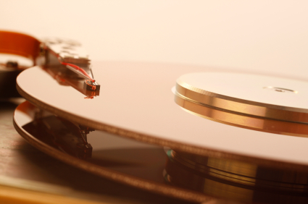

At the most basic level, internal storage is needed to hold the operating system so that the computer is able to access the input and output devices.

It will also be used to store the applications software that you use and more than likely, the original copies of your data files.

Internal storage allows the data and applications to be loaded very rapidly into memory, ready for use. The data can be accessed much faster than data which is stored on an external storage device. This is because internal storage devices are connected directly to the motherboard and its data bus whereas external devices are connected through a hardware interface such as USB, which means they are considerably slower to access.

Internal storage also means that if the computer is moved around, it will still retain its most commonly used data.

The main disadvantage of internal storage is that when the hard disk fails (and it will), all the data and applications may be lost.

This can be avoided to some extent by using more than one hard disk within the machine. Each hard disk has a copy of all the data, so if one fails the other can carry on. This is called a RAID array. An alternative is to use external drives for backup

Interfacing ports

© www.teach-ict.com

## Characteristics of Ports

A port has the following characteristics −

* External devices are connected to a computer using cables and ports.
* Ports are slots on the motherboard into which a cable of external device is plugged in.
* Examples of external devices attached via ports are the mouse, keyboard, monitor, microphone, speakers, etc.

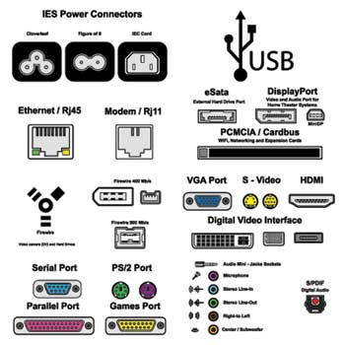

Let us now discuss a few important types of ports −

## Serial Port

* Used for external modems and older computer mouse
* Two versions: 9 pin, 25 pin model
* Data travels at 115 kilobits per second

## Parallel Port

* Used for scanners and printers
* Also called printer port
* 25 pin model
* IEEE 1284-compliant Centronics port

## PS/2 Port

* Used for old computer keyboard and mouse
* Also called mouse port
* Most of the old computers provide two PS/2 port, each for the mouse and keyboard
* IEEE 1284-compliant Centronics port

## Universal Serial Bus (or USB) Port

* It can connect all kinds of external USB devices such as external hard disk, printer, scanner, mouse, keyboard, etc.
* It was introduced in 1997.
* Most of the computers provide two USB ports as minimum.
* Data travels at 12 megabits per seconds.
* USB compliant devices can get power from a USB port.

## VGA Port

* Connects monitor to a computer's video card.
* It has 15 holes.
* Similar to the serial port connector. However, serial port connector has pins, VGA port has holes.

## Power Connector

* Three-pronged plug.
* Connects to the computer's power cable that plugs into a power bar or wall socket.

## Firewire Port

* Transfers large amount of data at very fast speed.
* Connects camcorders and video equipment to the computer.
* Data travels at 400 to 800 megabits per seconds.
* Invented by Apple.
* It has three variants: 4-Pin FireWire 400 connector, 6-Pin FireWire 400 connector, and 9-Pin FireWire 800 connector.

## Modem Port

* Connects a PC's modem to the telephone network.

## Ethernet Port

* Connects to a network and high speed Internet.
* Connects the network cable to a computer.
* This port resides on an Ethernet Card.
* Data travels at 10 megabits to 1000 megabits per seconds depending upon the network bandwidth.

## Game Port

* Connect a joystick to a PC
* Now replaced by USB

## Digital Video Interface, DVI port

* Connects Flat panel LCD monitor to the computer's high-end video graphic cards.
* Very popular among video card manufacturers.

## Sockets

* Sockets connect the microphone and speakers to the sound card of the computer.